HOSPITAL OPERATION & PATIENT ANALYSIS DASHBOARD
MILESTONE 1
Data Collection and Preparation Documentation

1. Understand the Four Datasets
Dataset Structure and Data Grain
The project uses four analytical datasets, each designed according to the required purpose and data grain:

Dataset | Purpose | One Row Represents
Hospital Overview | Admission and hospital performance | One admission
Patient Flow | Patient movement | One movement event
Department Analytics | Department performance | One hospital + department + day
Resource Utilization | Resource usage | One hospital + department + day + resource type

- The four datasets are connected through common fields while maintaining their individual data grains.
- This structure allows each dataset to be analyzed independently as well as together in the Tableau dashboard.
- The different grains are important because one admission can have multiple patient movement events, so the datasets should not be directly joined row-by-row without considering their grain.

2. Dataset Selection
- Publicly available datasets were explored, but they did not provide the required connectivity between the four analytical areas.
- Therefore, synthetic datasets were generated specifically for this project, following the required purpose, structure, and data grain.
- The datasets contain common fields that allow them to be connected and analyzed together.
- The main joining fields are:

Dataset Connection | Joinable Columns | Relationship Purpose
Hospital Overview ↔ Patient Flow | admission_id, patient_id, hospital_id | Connect admission records with patient movement events
Hospital Overview ↔ Department Analytics | hospital_id, department_id, admission_date ↔ date | Connect admissions with daily department performance
Department Analytics ↔ Resource Utilization | hospital_id, department_id, date | Connect daily department performance with resource usage
Patient Flow ↔ Department Analytics | hospital_id, current_department_id ↔ department_id, movement_date ↔ date | Analyze patient movements against department performance

- The datasets were designed with different grains, so relationships are defined according to the level of detail rather than simply combining all records row-by-row.
- This structure allows the four datasets to work as a connected hospital analytics system for the Tableau dashboard.

Important Relations Between Datasets
1. Hospital Overview → Patient Flow
Join key: admission_id
Because admission_id identifies one admission, while Patient Flow can contain multiple movement events for that admission. So this is naturally 1-to-many.
2. Department Analytics → Resource Utilization
Join key: hospital_id + department_id + date
This is the best match because both datasets have the same daily hospital-department grain, except Resource Utilization additionally has resource_type.
3. Hospital Overview → Department Analytics
Use: hospital_id + department_id + admission_date = date
But remember: this is not a 1-to-1 relationship. One department has one daily record, while many admissions can occur on that day.

The datasets are connected through common business keys while preserving their individual data grains. This enables integrated analysis without treating records from different grains as one-to-one records.

3. Dataset Finalization and Validation
- A dataset validation table was prepared in Excel before starting the data-cleaning process.
- The table evaluates all four datasets based on the required criteria, including source, URL, row and column counts, available fields, missing values, duplicates, date coverage, join keys, and required project fields.
- All four datasets contain the required fields and have no required project fields missing, making them suitable for the intended analytical areas.
- The datasets also contain sufficient hospital, department, patient, and resource information and provide possible join keys for connecting the datasets.
- Based on the validation, each dataset was finalized for its respective analytical purpose:

Dataset | Finalization Justification
Hospital Overview | Suitable for Hospital Overview because it contains admission, patient, hospital, department, billing, diagnosis, and outcome information.
Patient Flow | Suitable for Patient Flow because it contains patient movement, admission, department, and movement-date information.
Department Analytics | Suitable for Department Analytics because it contains daily hospital and department performance, staffing, admission, occupancy, and efficiency information.
Resource Utilization | Suitable for Resource Utilization because it contains hospital and department resource availability, usage, capacity, downtime, and utilization information.

Validation Summary
- 4 datasets validated
- All required project fields available
- No required fields missing
- Common join keys available
- Different data grains maintained
- Datasets finalized for the four required analytical areas

Validation Spreadsheet Link:

https://docs.google.com/spreadsheets/d/1lC_r7w5oqRSx7-zQ4dMLrPXILAwgG75F/edit?usp=sharing&ouid=114994134267732286980&rtpof=true&sd=true

PREVIEW OF THE SPREADSHEET :

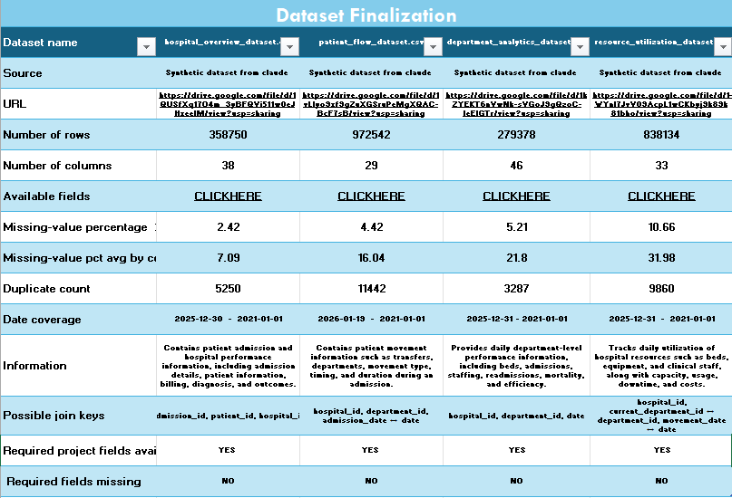

4. Do Not Force Missing Features
- The four finalized datasets contain the required project features and columns needed for their respective analytical areas.
- Each field was reviewed and verified based on its column name and business meaning to ensure it is relevant to the intended analysis.
- No unrelated fields were renamed or incorrectly mapped to represent missing features.
- As all required features are available, no supplementary sources or artificial feature mappings were required.
- The datasets were therefore finalized without any missing required analytical features.

5. Data Collection and Project Structure
- A structured MedTrack_DV project folder was created with separate folders for raw data, processed data, notebooks, scripts, dashboards, and documentation, following the required project structure.
- All original datasets are maintained unchanged inside data/raw/.
- The raw datasets are accessed separately for the cleaning and transformation process, and the cleaned datasets are saved as new files inside data/processed/.
- This ensures that the original data is preserved and the complete ETL process can be reproduced whenever required.
- The same organized folder structure will also be maintained when the project is uploaded to GitHub.

PROJECT FOLDER STRUCTURE:

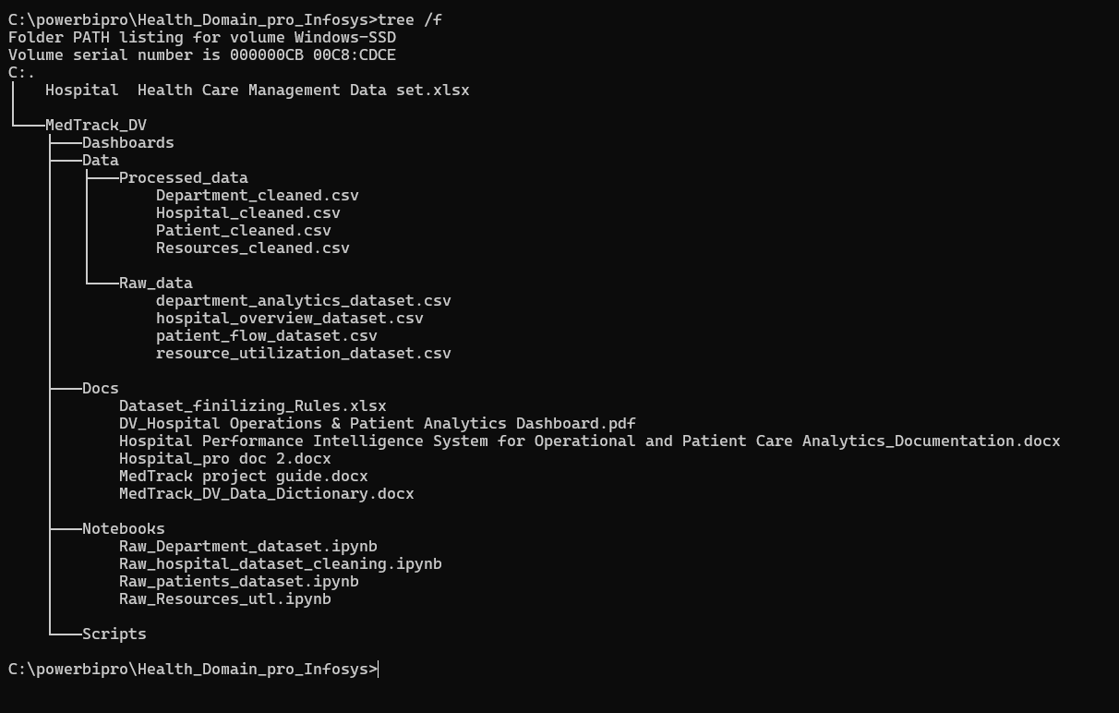

6. Data Profiling
These are the things which we need to know before performing the cleaning of the dataset properly:

Checks | Hospital dataset | Patient dataset | Department dataset | Resources utilization
How many records are available? | 358750 | 972542 | 279378 | 838134
What does one row represent? | One row = one admission | One row = one patient movement event | One row = one hospital + department + day | One row = one hospital + department + day + resource type
Which columns are identifiers? | admission_id | movement_id | dept_analytics_id | resource_utilization_id
Which columns are numerical? | Room_number  Length_of_stay_days  Patient_age  Total_bill_amount  Patient_satisfaction_score  Mortality_flag  Admission_year  Admission_month  Admission_quarter  Readmission_flag  Readmission_within_30_days | Movement_sequence  Movement_year  Movement_month  Hour_of_day  Duration_in_department_hours  Ward_occupancy_pct_at_time  Length_of_stay_days | Year  Month  Quarter  Floor_number  Established_year  Total_beds  Occupied_beds_count  Bed_occupancy_rate_pct  Target_occupancy_rate_pct  Patients_admitted_count  Patients_discharged_count  Readmission_count  Readmission_rate_pct  Target_readmission_rate_pct  Mortality_count  Mortality_rate_pct  Avg_length_of_stay_days  Target_avg_los_days  Avg_treatment_time_hours  Transfer_events_count  Bed_turnaround_time_hours  Nurses_on_duty  Doctors_on_duty  Base_nurses_per_shift  Base_doctors_per_shift  Staff_to_patient_ratio  Equipment_downtime_hours  Avg_patient_age  Avg_satisfaction_score  Total_billing_usd  Avg_cost_per_patient_usd  Monthly_budget_allocated_usd  Department_efficiency_score | Year  Month  Quarter  Total_units_available  Units_in_use  Units_under_maintenance  Utilization_rate_pct  Capacity_hours  Utilized_hours  Idle_hours  Downtime_hours  Nurses_on_duty_snapshot  Doctors_on_duty_snapshot  Overtime_hours  Avg_response_time_minutes  Cost_per_day_usd  Planned_capacity_next_month
Which columns are categorical? | Admission_type  Admission_source  Bedtype  Patient_gender  Insurance_type  Payment_status  Discharge_status  Is_weekend_admission | Movement_type  From_dept_name  Current_dept_name  From_location  Current_location  Bed_type  Mode_of_transport  Reason_for_movement  Day_of_week  Shift  Is_peak_hour | Day_of_week  Is_weekend  Dept_name  Dept_type  Is_24x7 | Day_of_week  Is_weekend  Dept_name  Resource_type  Resource_category  Shortage_flag  Maintenance_due_flag
Which columns contain dates? | Admission_date  Discharge_date  Last_updated_timestamp  Admission_year | Movement_date  Movement_datetime | Date  Last_updated_timestamp | Date  Last_maintenance_date  Last_updated_timestamp
Which columns contain missing values? | discharge_date  room_number  length_of_stay_days  patient_age  patient_gender  attending_doctor_name  diagnosis_description  insurance_type  total_bill_amount  payment_status  discharge_status  patient_satisfaction_score  previous_admission_id | from_department_id  from_department_name  bed_id  mode_of_transport  authorized_by_staff  reason_for_movement  duration_in_department_hours  ward_occupancy_pct_at_time | department_head_name  readmission_rate_pct  mortality_rate_pct  avg_length_of_stay_days  avg_treatment_time_hours  bed_turnaround_time_hours  staff_to_patient_ratio  avg_patient_age  avg_satisfaction_score  total_billing_usd  avg_cost_per_patient_usd | units_under_maintenance  utilization_rate_pct  downtime_hours  nurses_on_duty_snapshot  doctors_on_duty_snapshot  overtime_hours  avg_response_time_minutes  cost_per_day_usd  resource_condition  last_maintenance_date  planned_capacity_next_month
Which columns contain duplicates? | admission_id | movement_id | dept_analytics_id | resource_utilization_id

7. Data Cleaning and Transformation
After understanding, validating, and finalizing the four datasets, the data-cleaning process is started. Each dataset is cleaned separately while preserving the original raw files.

The cleaning process will be performed step by step, with every transformation reviewed and validated before creating the final processed datasets.

Data Cleaning Flow
1. Initial Data Profiling
2. Column & Structure Cleaning
3. Duplicate Record Handling
4. Missing Value Handling
5. Categorical & Text Standardization
6. Data Type Correction
7. Date & Time Cleaning
8. Numerical Data Cleaning & Outlier Handling
9. Data Consistency & Validation
10. Final Clean Dataset

Approach
- The cleaning process will be applied individually to each of the four datasets.
- Every step will be documented with what was changed and why it was required.
- The original files in data/raw/ will remain unchanged.
- The cleaned datasets will be saved separately in data/processed/.
- After cleaning, the processed datasets will be validated again before moving to KPI engineering and dashboard development.

7.1 Hospital Overview Dataset Cleaning
Dataset Overview
After loading the dataset into Python using the Pandas library, an initial overview of the dataset was performed.
- The first few records were displayed using the .head() function to understand the structure and values of the dataset.
- Since Pandas may truncate the number of columns displayed, the display option was adjusted using pd.set_option('display.max_columns', ...) to view all columns at once.
- This initial inspection helped us understand the overall structure and contents of the dataset before starting the cleaning process.

Dataset Shape and Summary Before Cleaning
Before performing any cleaning operations, the dataset was analyzed to understand its initial condition.
- The .shape function was used to identify the total number of rows and columns in the dataset.
- The .dtypes function was used to identify the data type of each column.
- The .describe() function was used to generate a statistical summary of the numerical columns, including count, mean, standard deviation, minimum, maximum, and quartile values.
- The .describe(include="all") function was then used to obtain a broader summary of both numerical and categorical columns.
- Overall duplicate records were identified using .duplicated().sum().
- Column-level repeated values were also examined by iterating through the columns.
- Missing values were identified using .isnull().sum(), and columns containing missing values were filtered for further investigation.
- The percentage of missing and duplicate records was also calculated to understand the extent of data-quality issues.
- Finally, the minimum and maximum dates were examined to determine the date coverage of the dataset.

Duplicate Record Analysis and Removal
The cleaning process was started with duplicate record analysis.
- Duplicate records were handled first because removing unnecessary duplicate records can reduce the dataset size and simplify subsequent cleaning operations.
- Before removing duplicates, the reason for the duplication was investigated rather than deleting the records immediately.
- Since admission_id represents the admission record, duplicate admission IDs were examined using:
hospital_df[hospital_df['admission_id'].duplicated(keep=False)].sort_values('admission_id')
- The duplicate records were manually examined to determine whether they were exactly repeated records or contained different information under the same identifier.
- The examination showed that the records were repeated, so the duplicate records were removed using .drop_duplicates(), keeping the first occurrence with the keep parameter.
- After removing the duplicates, .duplicated().sum() was used again to verify that the duplicate records had been successfully removed.

Missing Value and Data Standardization
1. Discharge Date — Missing values were replaced with the most frequently occurring date (mode).
2. Room Number — Missing values were replaced using the mode. The column was converted to int64.
3. Length of Stay (Days) — Missing values were replaced with the representative value 5 days. Converted to int64.
4. Patient Age — Missing values were replaced with the representative value 47 years. Converted to int64.
5. Patient Gender — Missing values were replaced with 'Others'. Inconsistent values (M, m, male, Male, F, f, female, Female) were standardized into Male, Female, and Others.
6. Attending Doctor Name — Missing values were replaced with the frequently appearing doctor name Dr. Daniel Brown.
7. Diagnosis Description — Missing values were replaced with 'NOT AVAILABLE' to clearly indicate unavailable information.
8. Insurance Type — Missing values were replaced with Medicare/Medicaid. Different representations were standardized.
9. Total Bill Amount — Dollar symbols were removed. Column converted to numeric. Missing values replaced with 8144.22.
10. Payment Status — Leading and trailing spaces removed using strip(). Missing values replaced with Partially Paid.
11. Discharge Status — Different representations (nan, NAN, blank) standardized. Missing values replaced with Discharged.
12. Patient Satisfaction Score — Missing values replaced using the mean value of the column.
13. Previous Admission ID — Missing values replaced with 'NOT AVAILABLE', as some admissions may not have a previous record.

Cleaning Outcome
- Missing values were handled according to the nature and business meaning of each column.
- Inconsistent categorical values were standardized.
- Numerical and date-related columns were converted into appropriate formats.
- The cleaned dataset was prepared for further analysis.

Correction of Column Names, Values and Data Types
- Column Name Standardization: The first letter of each column name was converted to uppercase using .str.capitalize().
- ID Data Type Correction: Identifier columns (Admission_id, Patient_id, Hospital_id, Department_id) were converted from numerical types to string.
- Removing Extra Spaces: Leading and trailing spaces were removed from categorical fields using .str.strip().
- Categorical Value Standardization: Values in Admission_type, Admission_source, Insurance_type, Payment_status, and Discharge_status were standardized using .str.capitalize().

Standardize IDs
- The ID columns did not contain inconsistent formats such as P001, p001, P-001, or P 001; therefore, no additional ID normalization was required.
- The existing IDs were originally stored as numerical values, so they were converted to string data types to treat them strictly as identifiers.
- This ensures that the IDs remain consistent and unchanged during data processing and can be reliably used as join keys when connecting the four datasets.

Standardization of Dates
- The columns Admission_date, Discharge_date, and Last_updated_timestamp were initially stored as object data types.
- These columns were converted to the appropriate datetime data type using the pd.to_datetime() function.
- The project requirements also mention creating time-based fields such as Year, Month, and Quarter from the date columns.
- However, these fields were already available in the dataset, so no additional Year, Month, or Quarter columns were created.

Standardization of Departments & Others
1. Department Names:
- The department names were standardized to ensure consistent and accurate department information across the dataset.
- The appropriate department name for each Department_id was manually identified and stored as key-value pairs in a dictionary.
- The dictionary was then mapped to the Department_id column using the Pandas .map() function.

2. Diagnosis Description:
- Unique combinations of Diagnosis_code and Diagnosis_description were identified using grouping and duplicate removal.
- The mapping dictionary was applied to the Diagnosis_code column using .map() to assign the corresponding diagnosis description.

3. Attending Doctor Name:
- Unique Attending_doctor_id and Attending_doctor_name combinations were identified for manual verification.
- A mapping between doctor ID and doctor name was created using a dictionary/dataframe-based mapping approach.

Outlier Validation
- Length of Stay Days — Outlier values such as 400 and 999 were replaced with the mean value of 5.0 days. Negative values were converted to positive using abs().
- Patient Age — Outlier values such as 150, 250, and 199 were replaced with the representative mean value of 47 years. Negative values converted using abs().
- Total Bill Amount — Negative bill amounts were converted to positive using abs(). Values were rounded to 2 decimal places.

7.2 Patient Flow Dataset Cleaning
This two sections are similar to all remaining datasets so we don’t need to write it again.

Dataset Overview
Dataset Shape and Summary Before Cleaning

Duplicate Record Analysis and Removal
The cleaning process was started with duplicate record analysis.
- Since movement_id represents the movement record, duplicate movement IDs were examined using:
hospital_df[hospital_df['movement_id'].duplicated(keep=False)].sort_values('movement_id')
- The duplicate records were removed using .drop_duplicates(), keeping the first occurrence.
- After removing the duplicates, .duplicated().sum() was used again to verify successful removal.

Missing Value and Data Standardization
1. From Department ID — Missing values filled by randomly selecting from existing unique department IDs using NumPy's random.choice(). Converted to string data type.
2. From Department Name — Leading/trailing spaces removed. Inconsistent names (e.g., Cardiology, Cardio, Cardiology dept) standardized using a department ID mapping dictionary.
3. Bed ID — Missing values replaced with the frequently occurring bed ID B0379.
4. Mode of Transport — Missing values replaced with the frequently occurring value Ambulatory.
5. Authorized By Staff — Missing values replaced with the frequently occurring value Ann Diaz, RN.
6. Reason for Movement — Missing values replaced with the frequently occurring value Routine discharge.
7. Duration in Department Hours — Missing values replaced using the average value of 67.307004 hours.
8. Ward Occupancy Percentage at Time — Missing values replaced using the average value of 67.428988%.

Correction of Column Names, Values and Data Types
- Column Names — First letter of each column name capitalized using .str.capitalize().
- ID Columns — All columns ending with _id were identified programmatically and converted to string data type.
- From Location, Mode of Transport, Reason for Movement, Shift, Hospital Name, Movement Type, To Location — Leading/trailing spaces removed and values standardized using .str.capitalize().

Standardize IDs:
This two sections are similar to all remaining datasets so we don’t need to write it again.

Standardization of Departments:

Standardization of Dates
- The columns Movement_date and Movement_datetime were initially stored as object data types and converted using pd.to_datetime().
- Year and Month fields were already available in the dataset, so no additional time-based columns were created.

Outlier Validation
- Duration in Department Hours — The column was removed because its information was redundant with the existing Length of Stay field.
- Ward Occupancy Percentage at Time — Negative values were identified as invalid and converted to positive values using the abs() function.

7.3 Department Analysis Dataset Cleaning
This two sections are similar to all remaining datasets so we don’t need to write it again.

Dataset Overview
Dataset Shape and Summary Before Cleaning

Duplicate Record Analysis and Removal
Since dept_analytics_id represents the unique record, duplicate dept_analytics_ids were examined using:
department_df[department_df['dept_analytics_id'].duplicated(keep=False)].sort_values('dept_analytics_id')
- Duplicate records were removed using .drop_duplicates(), keeping the first occurrence.

Missing Value and Data Standardization
1. Department Head Name — Missing values replaced with the frequently occurring name Dr. Ivan Smith.
2. Readmission Rate Percentage — Recalculated using Readmission_count and Patients_admitted_count. Division by zero cases replaced with 0.
3. Mortality Rate Percentage — Missing values replaced with 0, as missing values resulted from cases where both values used in the calculation were zero.
4. Average Length of Stay Days — Missing values replaced using the calculated mean value of 5.53 days.
5. Average Treatment Time Hours — Missing values replaced using the calculated mean value of 67.68 hours.
6. Bed Turnaround Time Hours — Missing values replaced using the calculated mean value of 3.20 hours.
7. Staff to Patient Ratio — Missing values handled by recalculating the ratio using Nurses_on_duty and Occupied_beds_count.
8. Average Patient Age — Missing values replaced using the calculated mean value of 47.8 years.
9. Average Satisfaction Score — Missing values replaced using the calculated mean value of 3.30.
10. Total Billing USD — Missing values replaced using the mean value of the column.
11. Average Cost per Patient USD — Dollar symbols ($), commas, and the USD text removed. Converted to float. Missing values replaced with mean.

Correction of Column Names, Values and Data Types
- Hospital Name, Department Type, Record Source System — Leading/trailing spaces removed and values standardized using .str.capitalize().
- Percentage, Ratio, and Financial Columns — Floating-point values rounded to 2 decimal places for consistent presentation.
- Patient and Event Count Columns — Count-based columns (Patients_admitted_count, Patients_discharged_count, Readmission_count, Mortality_count, Transfer_events_count) converted to integer data type.

Standardize IDs:
This two sections are similar to all remaining datasets so we don’t need to write it again.

Standardization of Departments:

Standardization of Dates
- The columns Date and Last_updated_timestamp were initially stored as object data types and converted using pd.to_datetime().
- Year and Month fields were already available in the dataset, so no additional time-based columns were created.

Outlier Validation
- Average Length of Stay Days — Negative values converted to positive using abs().
- Average Treatment Time Hours — Negative values converted to positive using abs().
- Average Patient Age — Negative values converted to positive using abs().

7.4 Resources Utilization Analysis Dataset Cleaning
This two sections are similar to all remaining datasets so we don’t need to write it again.

Dataset Overview
Dataset Shape and Summary Before Cleaning

Duplicate Record Analysis and Removal
Since resource_utilization_id represents the unique record, duplicate IDs were examined using:
resource_df[resource_id['resource_utilization_id'].duplicated(keep=False)].sort_values('resource_utilization_id')
- Duplicate records were removed using .drop_duplicates(), keeping the first occurrence.

Missing Value and Data Standardization
A mean calculation function was created to calculate the average of the available non-null values and use it for filling missing numerical values.
1. Units Under Maintenance — Missing values replaced using the calculated mean value.
2. Utilization Rate Percentage — Recalculated using Units_in_use and Total_units_available. Values rounded to 2 decimal places.
3. Downtime Hours — Missing values replaced using the calculated mean value.
4. Nurses on Duty Snapshot — Missing values replaced using the calculated mean value.
5. Doctors on Duty Snapshot — Missing values replaced using the calculated mean value.
6. Overtime Hours — Missing values replaced using the calculated mean value.
7. Average Response Time Minutes — Missing values replaced using the calculated mean value.
8. Cost per Day USD — Dollar symbols, commas, and USD text removed. Converted to float. Missing values replaced with mean.
9. Resource Condition — Missing values replaced with the frequently occurring value Functional.
10. Last Maintenance Date — Converted to date format. Missing values replaced using the earliest available maintenance date.
11. Planned Capacity Next Month — Missing values replaced using the calculated mean value.

Correction of Column Names, Values and Data Types
- Resource Type, Resource Category, Resource Condition, Hospital Name, Record Source System — Leading/trailing spaces removed and values standardized using .str.capitalize().

Standardize IDs:
This two sections are similar to all remaining datasets so we don’t need to write it again.

Standardization of Departments:

Standardization of Dates
- The columns Date, Last_maintenance_date, and Last_updated_timestamp were initially stored as object data types and converted using pd.to_datetime().
- Year and Month fields were already available in the dataset, so no additional time-based columns were created.

Outlier Validation
- Nurses on Duty Snapshot — Negative values converted to positive using abs().
- Doctors on Duty Snapshot — Negative values converted to positive using abs().
- Overtime Hours — Negative values converted to positive using abs().
- Cost per Day USD — Negative values converted to positive using abs().
This process ensured that the affected numerical columns contained positive and analysis-ready values for resource utilization analysis.

8. Relationship Validation
A separate document for relationship validation has been prepared in the same location as this file.

9. Create the Four Final Tables
- After completing the data cleaning and transformation process, four final analytical datasets were created using the Pandas .to_csv() function.
- The cleaned DataFrames — hospital_cleaned, patient_cleaned, department_cleaned, and resources_cleaned — were exported as CSV files.
- The files were saved in the data/processed/ folder according to their respective analytical areas.
- These processed datasets will serve as the final data sources for developing the four Tableau dashboards.

Final Processed Datasets
Cleaned DataFrame | Final CSV File
hospital_cleaned | hospital_overview_dataset.csv
patient_cleaned | patient_flow_dataset.csv
department_cleaned | department_analytics_dataset.csv
resources_cleaned | resource_utilization_dataset.csv

